**Colonial Protests**

**A. Stamp Act.** The colonists expressed their outrage in many ways. But which kinds of protest would be most effective at convincing Great Britain to repeal the Stamp Act? (It did repeal the Act in 1766.) Evaluate the different responses to the Stamp Act below. Do you think these would be effective forms of protest (or capable of causing change), and why?

1) Boycotting British goods.

*Is this an effective form of protest? Why?*

2) Burning the governor in effigy (i.e. a doll/image of him).

*Is this an effective form of protest? Why?*

3) Rioting in the streets.

*Is this an effective form of protest? Why?*

4) Destroying paper and the tax stamps before they can be used by British officials.

*Is this an effective form of protest? Why?*

5) Writing letters to King George III and Parliament asking them to end the Stamp Act.

*Is this an effective form of protest? Why?*

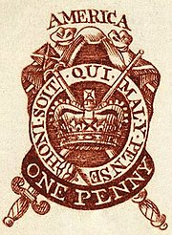

**B. Boston Tea Party.** Do you think that the colonial protests during the Boston Tea Party were effective forms of protest against the British? Why or why not? Use the image below, as well as your notes and what we learned about protests and the goals of the colonists, as evidence. Write a paragraph of 4-5 sentences.

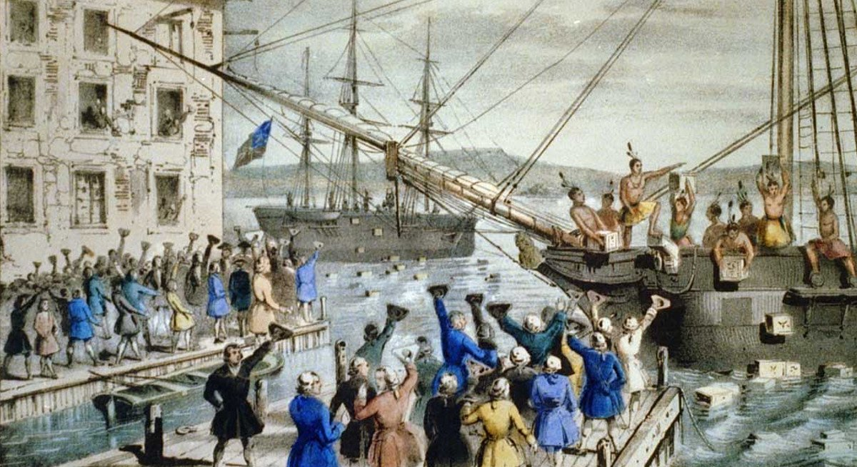

**ANSWER:**

I think that:

_______________________________________________________________________________________

_______________________________________________________________________________________

_______________________________________________________________________________________

_______________________________________________________________________________________

_______________________________________________________________________________________

_______________________________________________________________________________________

_______________________________________________________________________________________

_______________________________________________________________________________________

_______________________________________________________________________________________

_______________________________________________________________________________________